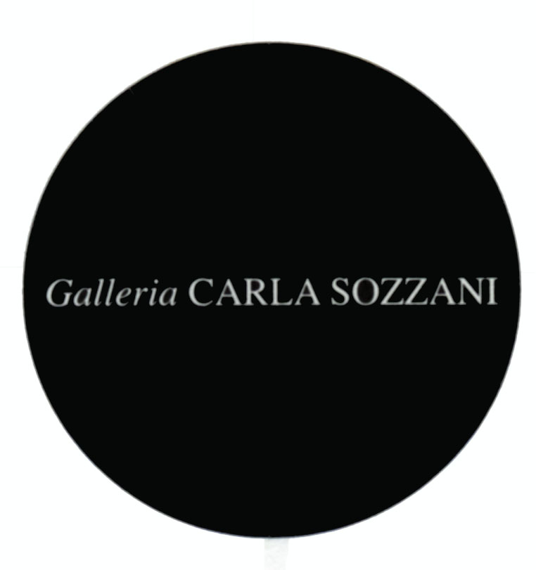

PRESS RELEASE

BERENICE ABBOTT

opening Saturday 9th November 2013

from 3.00 pm to 8.00 pm

cocktails

on show from 10th November 2013 to 6th January 2014
Tuesday, Friday, Saturday, Sunday, 10.30 am – 7.30 pm
Wednesday and Thursday 10.30 am – 9.00 pm
Monday, 3.30 pm – 7.30 pm

Galleria Carla Sozzani
Corso Como 10 – 20154 Milano, Italia
tel. +39 02.653531 fax +39 02.29004080
press@galleriacarlasozzani.org
www.galleriacarlasozzani.org

BERENICE ABBOTT

Photography can never grow up if it imitates some other medium.
It has to walk alone; it has to be itself.”

Berenice Abbott

Presenting an exhibition of Berenice Abbott with a discrete selection from a career that influenced the fields of portraiture, urban landscape, and innovative scientific photography, Galleria Carla Sozzani introduces a new audience to the depth of Berenice Abbott’s aesthetic.

Berenice Abbott is one of America's most outstanding photographers of the 20th century. She fashioned an extensive body of work in a career that explored and helped to define documentary photography and photographic realism. In opposition to the Pictorialism school of Alfred Stieglitz, Berenice Abbott’s images were precise presentations of the real world — visible and invisible — with flinty exactitude and scientific precision.

Born in Ohio in 1898, Berenice Abbott dropped her study of journalism at the University of Ohio, and moved to New York City to study sculpture. In the early 1920s, she moved again, this time to Paris where she joined the artistic and avant-garde intellectuals who were flooding into the city. She was introduced to Man Ray, also a New Yorker, and became his assistant. It was Man Ray who introduced her to the photographs of Eugène Atget and set her direction.

In 1926 she established her own photography studio and rapidly launched a successful career taking portraits of all the writers, playwrights and artists in her circle of friends. James Joyce, Eugène Atget, Marcel Duchamp, Man Ray, Jean Cocteau, Sylvia Beach, André Gide, Tsuguharu Foujita, Max Ernst, and Marie Laurencin among others, would come to sit in front of her lens.

Returning to New York City in 1929, Abbott conceives and shoots her best-known and most influential work, Changing New York. This portfolio of work represents a seminal study of an emerging metropolis. Documenting the dichotomy between past and present as New York re-invents itself after the Great Depression, her unique juxtaposition of the old and new alternate between a New Vision aesthetic characterised by an emphasis on details and bold perspectives, and a documentary style that is frontal and neutral. As Abbott herself said about this work, "In my own case with New York City - the contrasts, the fast changes inspired me. The look of a vibrant city needs detail texture, perspective."

In 1939 Abbott began her most ambitious technical explorations attempting to photograph scientific phenomena as photo-editor for the review Science Illustrated. Based on these works and her technical research, in 1958 she is hired by the Massachusetts Institute of Technology (MIT) to produce a series of illustrations on the principles of mechanics and light. Abbott saw this as an opportunity to make the abstract elegance and beauty of science visible and concrete. Harking back to her experiments in Paris in the ‘20’s, and in particular Man Ray’s rayogram technique, she produces a series of images that are still today rich in discovery and visual elegance, a unique combination of documentary information with a sense of wonder.

“Let us first say what photography is not. A photograph is not a painting, a poem, a symphony, a dance. It is not just a pretty picture, not an exercise in contortionist techniques and sheer print quality. It is or should be a significant document, a penetrating statement, which can be described in a very simple term: selectivity”.

Berenice Abbott from “Universal Photo Almanac”, 1951

