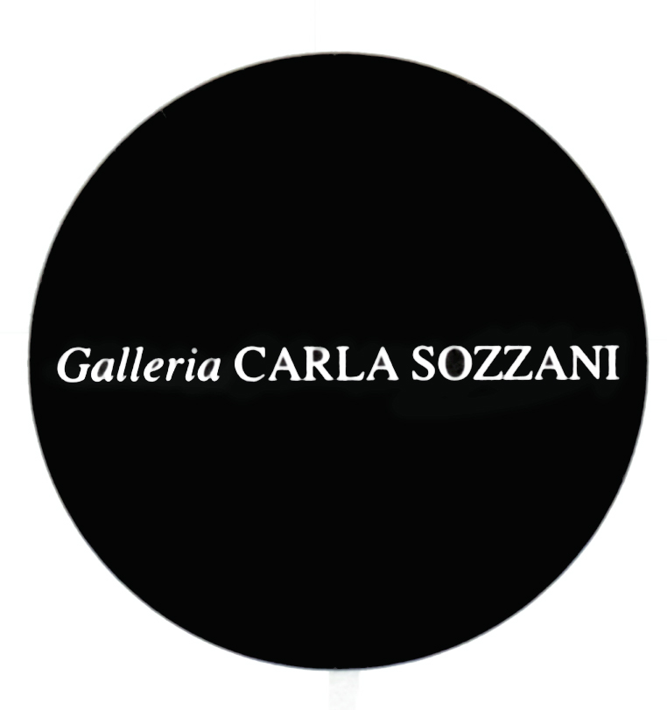

PRESS RELEASE

CHARLOTTE PERRIAND

photographer and designer

curated by Jacques Barsac and Enrica Viganò

opening Saturday 5th April 2014
from 3.00 pm to 8.00 pm

on show from 6th April to 4th May 2014
everyday, 10.30 am – 7.30 pm
Wednesday and Thursday, 10.30 am – 9.00 pm

In collaboration with Nicéphore Niépce Museum (Chalon-sur-Saône), Charlotte Perriand Archives (Paris), Admira (Milan) and Cassina.

Galleria Carla Sozzani

Corso Como 10 – 20154 Milano, Italia
tel +39 02.653531 fax +39 02.29004080
press@galleriacarlasozzani.org
www.galleriacarlasozzani.org

CHARLOTTE PERRIAND

photographer and designer

Architect, urban planner, designer, collaborator of Le Corbusier, ever solitary and tireless traveler, Charlotte Perriand, with a unique and unconventional wit, was a pivotal figure in design of the 20th century and influenced contemporary living in multiple ways.

During the 1930s, parallel to her work as a designer, Charlotte Perriand took photographs in her travels throughout Europe, which then became a source of inspiration for her projects, interiors, and fine art works.

The subjects followed each other in a gesture of intuitive choice: she recorded, noted, embossed shapes (and ideas) that captured her attention. And in this way, the metal structure of a bridge, the plot of a fisherman's net, even a stone, became a source of inspiration for the creation of her tables, bookcases and armchairs.

The discovery of hundreds of negatives preserved by the Charlotte Perriand Archives became an opportunity to investigate her photographic work in an extensive and articulated way. This exhibition wishes to bring Perriand’s ouevre to the attention of a wider audience. Perriand's photographs are less known compared to her design work but played a relevant role in the development of her creative process.

Photography to which Perriand dedicated many years in her career worked as a laboratory for her visual and philosophical research, as well as the manifesto of her political commitment. A selection of fifty five photographs from the Museum Nicéphore Niépce and the Charlotte Perriand Archives will be presented at the Galleria Carla Sozzani, together with Perriand’s vintage and modern designs, true icons of the 20th century.

Her photographic research falls within the sphere of the avant-garde movement, when artists, architects and photographers were working side by side in an atmosphere of sharing and where each way of expression was enriched by the "view" of the other. With this spirit and through her friendship with Fernard Lèger and Pierre Jeanneret, Perriand began collecting and photographing objects she found in nature: bones, skeletons, roots, stones ... "Our backpacks - as she wrote - were filled with these treasures ... we christened them with the name of "Art Brut." Between 1933 and 1937, she continued her photographic experiments, with the series named "Art Brut" and "found objects", referring to the idea of a return to nature as original beauty, purity of lines and inner force of physical materials.

Charlotte Perriand never exhibited or published her photographic work during her life, with the exception of some photomontages made for a public commission. Her pictures, as a rare expression of her creativity, were partly revealed in the retrospective at the Centre Pompidou in Paris in 2005, then in "Modernism, Designing a New World, 1914-1939" at the Victoria and Albert Museum in London 2006, followed by the exhibition "Charlotte Perriand, de la photographie au design" at the Petit Palais in Paris in 2011. Lastly in 2012, "Charlotte Perriand, la photographie pour un autre monde" was shown at the Musée Nicéphore Niépce in Chalon-sur-Saone, France.

CHARLOTTE PERRIAND

Charlotte Perriand was born in Paris on October 24th, 1903. She studied at the Union Centrale des Arts Décoratifs (UCAD) in Paris and at the age of twenty she decided to become an architect, a profession considered at that time exclusively a male domain. After graduating in Interior Design in 1925, she followed the Bauhaus statements and rejected the canons of traditional decoration to embrace the use of modern industrial materials.

In 1927, she began her collaboration with the architect Le Corbusier and Pierre Jeanneret at the famous Atelier at 35 Rue de Sèvres in Paris. In those years she started a deep photographic production with a 6 x 9 folding camera gifted by her husband. In 1928, along with René Herbst, Djo-Bourgeois, Jean Fouquet, Gerard Sandoz and Jean Puiforcat, she formed an avant-garde group named "L'unité de choc" which exposed her "salle à manger", designed in 1927, at the Salon des Artistes Décorateurs. Two years later, together with her avant-garde group, she founded the UAM (Union des Artistes Modernes). In 1930 she met Walter Gropius and Fernand Léger, with whom she established a close friendship and artistic collaboration.

Her concept of living was always marked by the need to combine technical and scientific knowledge of the materials in close relation to space, the way of living and to occupying it. In 1932 she abandoned her studio in Place Saint Sulpice and moved to Montparnasse. In the same period, during the Spanish Civil War, she took part in demonstrations alongside the Republicans, participating in the intellectual circles of the Communist Party, where she met Miró, Picasso, André Malraux and Blaise Cendrars.

After a decade-long collaboration with Le Corbusier and Pierre Jeanneret, with whom she signed important pieces of furniture, she abandoned the atelier in March 1937. In 1940 she was invited by the Japanese government as a consultant for the domestic production of industrial design. The Japanese experience had a wide influence over her way of thinking and working. She tried to apply the new industrial forms to the local tradition. In 1943 she moved to Indochina and in May of that year, she married Jacques Martin, with whom she had a daughter, Pernette.

She returned to Paris in 1946, and in 1951 became head of the French delegation at the IX Triennale of Milan "Furniture and Decoration." Furniture designed by Le Corbusier-Jeanneret-Perriand were reissued in 1964 by Cassina.

Between 1996 and 1999 she curated three major retrospectives dedicated to her work: "Charlotte Perriand Modernist Pioneer" at the Design Museum in London, "Charlotte Perriand Pioneer 20th century" at the Living Design Center Ozone in Tokyo and "Une connivence Charlotte Perriand-Fernand Léger" at the Musée National Fernand Léger.
She died on October 27th, 1999 in Paris.

Galleria Carla Sozzani

Corso Como 10 – 20154 Milano, Italia
tel +39 02.653531 fax +39 02.29004080
press@galleriacarlasozzani.org
www.galleriacarlasozzani.org

