10 Corso Como Shanghai celebrates its 3rd anniversary bringing for the first time in Asia the work of Patrick Demarchelier and his son Victor Demarchelier.

(September 2016, Shanghai) 10 Corso Como, the world’s first fashion and design concept store, opened its first store in China three years ago, in Shanghai. Dedicated to Art, Fashion, Music, Design and Cuisine, 10 Corso Como Shanghai since its opening has been promoting the “slow shopping” concept, bringing a unique and innovative shopping experience to Chinese consumers.
Next week, September 7th, 10 Corso Como Shanghai will celebrate its third anniversary, and once again will bring to customers and visitors the opportunity to meet and exchange culture, ideas and experiences through an exclusive programme of designers collaborations, pop ups and art exhibitions.

Highlight of 10 Corso Como 3rd anniversary celebrations will be Patrick and Victor Demarchelier exhibition opening cocktail on September 7th at the presence of 10 Corso Como founder Carla Sozzani.
On September 5th, Cybex, one of the most beloved children brand, will launch, for the first time in China, its capsule collection in collaboration with Jeremy Scott. And on September 10th, 10 Corso Como Shanghai will present the Fall Winter 2016 trends with a trunk show featuring the most iconic pieces of the fall winter collections.

Always at the forefront of lifestyle trends, and representative of gourmet excellence, 10 Corso Como is launching a new Café concept. From September 8th, 10 Corso Como Café, at 10 Corso Como Shanghai ground floor, will re-open with a brand-new look and menu featuring a wide selection of salads, Panini and desserts by Michelin Star Chef Corrado Michelazzo.
From September 8th to September 11th 10 Corso Como will partner up with Photo Shanghai at Shanghai Exhibition Center with a pop up store and Café, presenting a joint project with Illy coffee featuring emerging young Chinese artists.

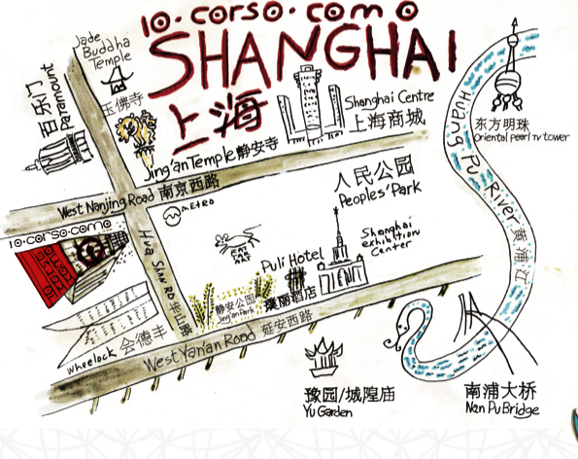

Patrick and Victor Demarchelier photography exhibition

10 Corso Como Shanghai in collaboration with Camera Works is pleased to present the work of Patrick Demarchelier and his son Victor Demarchelier. The exhibition not only gives a comprehensive idea of the body of work of both artists but also points out the mutual artistic coinage. For the first time in Asia their collaborative work will be exhibited as well.

For multiple decades Patrick Demarchelier has been considered a leading photo artist within the fashion and nude genre. His works celebrate the top models’ beauty without suffocating their appearance in a construction of artificiality. While fashion photography usually works towards excesses to create distinction, he is leaving space for a certain genuine. Patrick Demarchelier's photographic body of work stands out due to its perfection as well as his very own ease that is reflected both in his photographic eye and his pictorial language. Key element of his works is exactly this suggestion that is free of contemplation and calculation.

Glamour becomes real, reality becomes glamorous: This leitmotiv marks the father's body of work as well as his son's Victor Demarchelier. This approach towards photography does not only create unique photographs, but also a recognition value due to a constant change according to the latest subject. A particular awareness becomes clear to the beholder when reflecting either body of work. Patrick Demarchelier's early work – together with his numerous main works presented in the exhibition – is considered to be the foundation of what will be expected of Victor Demarchelier in the future.

About Patrick Demarchelier
Patrick Demarchelier, born in 1943 near Paris, grew up with four brothers and his mother in Le Havre. For his 17th birthday, his stepfather bought him a Kodak camera, which sparked his enthusiasm for photography. A passion for the photographic profession evolved into setting a clear objective for his professional future. His curiosity and the desire for perfecting his photographic abilities made him move to Paris when he was twenty years old. While working in photo laboratories, he began perusing leading fashion magazines to study the visual language and aesthetics of prestigious photographers. Subsequently, Patrick Demarchelier advanced to one of the world’s most famous fashion photographers. His relocation to New York in 1975 accompanied his international breakthrough. Since the late 1970s, reputable fashion magazines like »Elle«, »Glamour«, »GQ«, »Mademoiselle«, »Vogue« or »Rolling Stone« have been publishing his works. Furthermore, Patrick Demarchelier has been working for prestigious international couture and jewelry houses, including Armani, Calvin Klein, Chanel, Dior, Versace or Yves Saint Laurent. The British Royal Family honored him especially when commissioning him, as the first non-British photographer, to portray a member of their family – Lady Diana. Patrick Demarchelier lives and works in New York.

About Victor Demarchelier
Victor Demarchelier, born and raised in New York, is the youngest son of Patrick Demarchelier. Just after Victor Demarchelier completed his economic studies, he started working in his father's studio to learn about the complexity of photography. Within the following ten years Victor Demarchelier managed to pursue the successful path of his father just in a new generation. With an independent aesthetic which however is coined by his father, Victor Demarchelier now works for magazines including »Vogue«, »Interview«, »GQ«, »Harper's Bazaar« and »V Magazine«. Victor Demarchelier lives and works in New York.

About 10 Corso Como
Launched in 1990 in Milan, Italy by Carla Sozzani, 10 Corso Como is a network of spaces rolled into one experience and was the world’s first concept store. It is dedicated to Art, Fashion, Music, Design and Cuisine and has been designed as a multifunctional area, where customers and visitors are encouraged to meet and exchange culture, ideas and experiences. Named after its location in Milan in an industrial building, today 10 Corso Como has locations in Milan, Seoul, Shanghai and Beijing.

10 Corso Como Shanghai
Add: North Annex Wheelock Square, No. 1717, West Nanjing Road, Jing’an District , Shanghai

Opening time：
Fashion & Design：10:00-22:00
1F Café：8:00-22:00
Lounge Bar：Monday - Friday: 11:00-24:00, Saturday – Sunday: 11:00 – 1:00
Restaurant：Lunch- 11:30-14:30
Dinner- Sunday to Thursday 18:00-22:30; Friday, Saturday 18:00-23:00

www.10corsocomo.cn
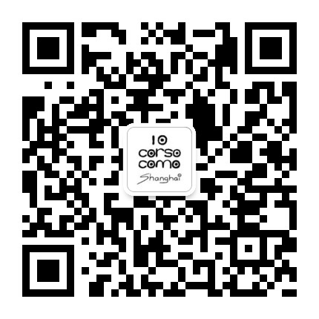

For media inquiry, please contact:
沈心远（Emma Shen）
+86 21 62188939-812
emma.shen@trendy-global.com
Marta Ricchetti
+86 21 62188939
marta.ricchetti@trendy-global.com

